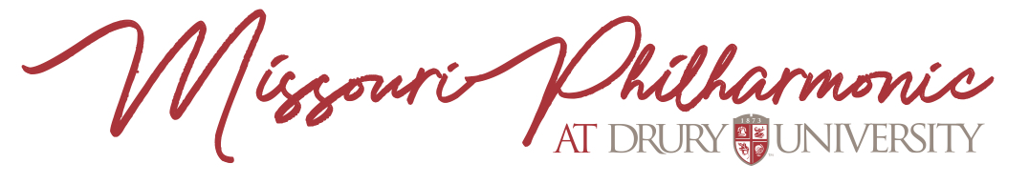
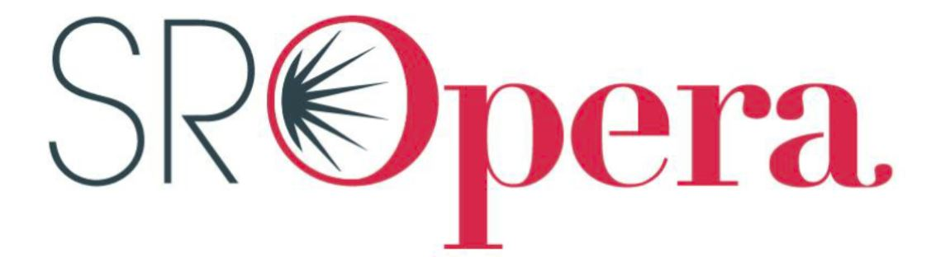

Springfield Regional Opera/Missouri Philharmonic
COLLABORATIVE ADVERTISING

Business Name: ______________________________________________________________________________________________________

Billing Address: ______________________________________________________________________________________________________

Phone Number: __________________________________________ Fax Number: ___________________________________________

Email: _______________________________________________________ Website:_____________________________________________

Representative: _____________________________________________________________________________________________________

Signature: ____________________________________________________________________________________________________________

Your ad will appear in all Springfield Regional Opera and Missouri Philharmonic event programs during the season including operas, large orchestra concerts, and special events. The typical opera/orchestra audience comprises established professionals and retirees with significant income as well as a strong collegiate and early professional presence.
Please circle the size of the promotion space you wish to purchase.
Size | Height and Width | Rate
Quarter Page Horizontal | 4 ½ inch x 1 ¾ inch | $380
Quarter Page Vertical | 2 1/8 inch x 3 5/8 inch | $380
Half Page  Horizontal | 4 ½ inch x 3 5/8 inch | $480
Half Page  Vertical | 2 ¼ inch x 7 ½ inch | $480
Full Page | 4 ½ inch x 7 ½ inch | $700
Inside Front Cover | 4 ½ inch x 7 ½ inch | $1000
Inside Back Cover | 4 ½ inch x 7 ½ inch | $1000
Please check one of the following. All copy and payments are due by September 1. Files must be at least 300 dpi. Send your camera-ready art to administration@sropera.org

❑ Renewal: Copy and/or Camera Ready Art included
❑ Renewal: New Copy and /or Camera Ready Art will be provided
❑ New: New Copy and/or Camera Ready Art included
❑ New: New Copy and /or Camera Ready Art will be provided
❑ Contact me about creating a unique ad for my business.
Terms: Purchaser agrees to pay for promotion space in the SRO/SDCO program book upon signing this contract.
Make checks payable to: “Missouri Philharmonic” or pay online at sdco.drury.edu
Missouri Philharmonic/Drury University
Attn: Christopher Koch
900 North Benton Ave.
Springfield, MO 65802
(417) 863-1960
www.sropera.org/sdco.drury.edu

